1)

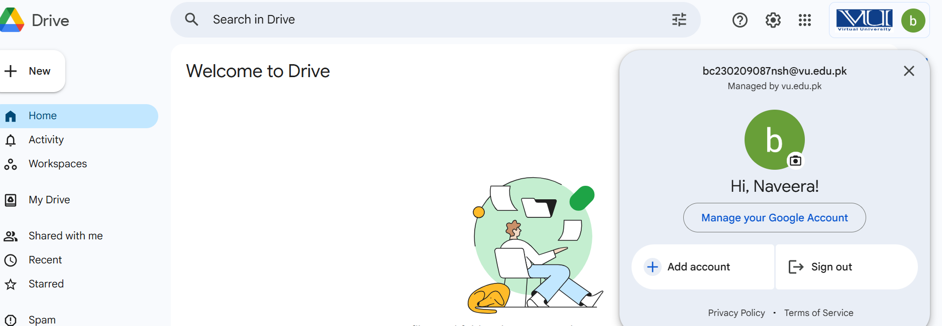

2)
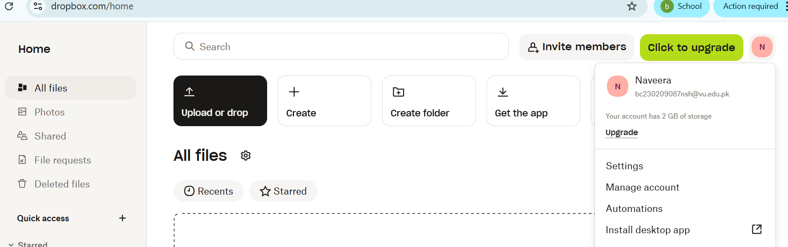

b)
I used google drive because a google account was already given by university and I used dropbox because it gives 2TB Free Storage.
Question no 2:

